**Set of queries to extract information from the system.**

* Once the Data is Populated in the database, you can view them all with the find () function. The usage of it given below:
  + db.airlineCompany.find();

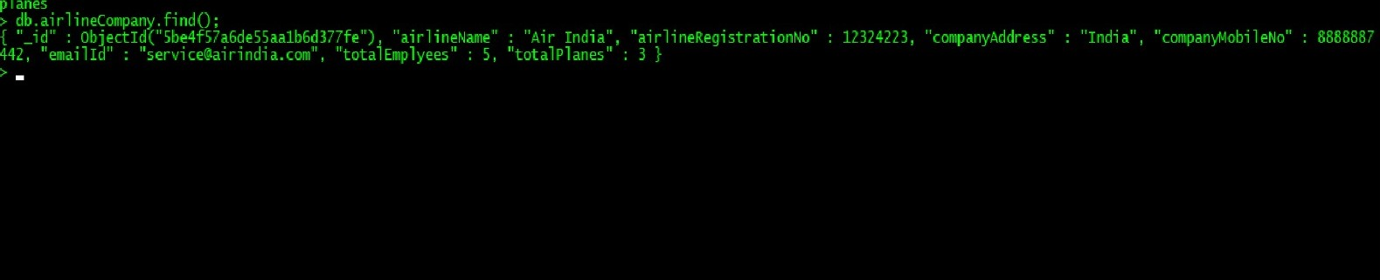

* This will give out all the documents present in the current collection. If you want to fetch the data with some constraints, you can specify them in the find() function like this:
  + db.collection_name.find({<field_name>: <parameter>});

For eg:

db.employee.find({deptId: “DEP02”});

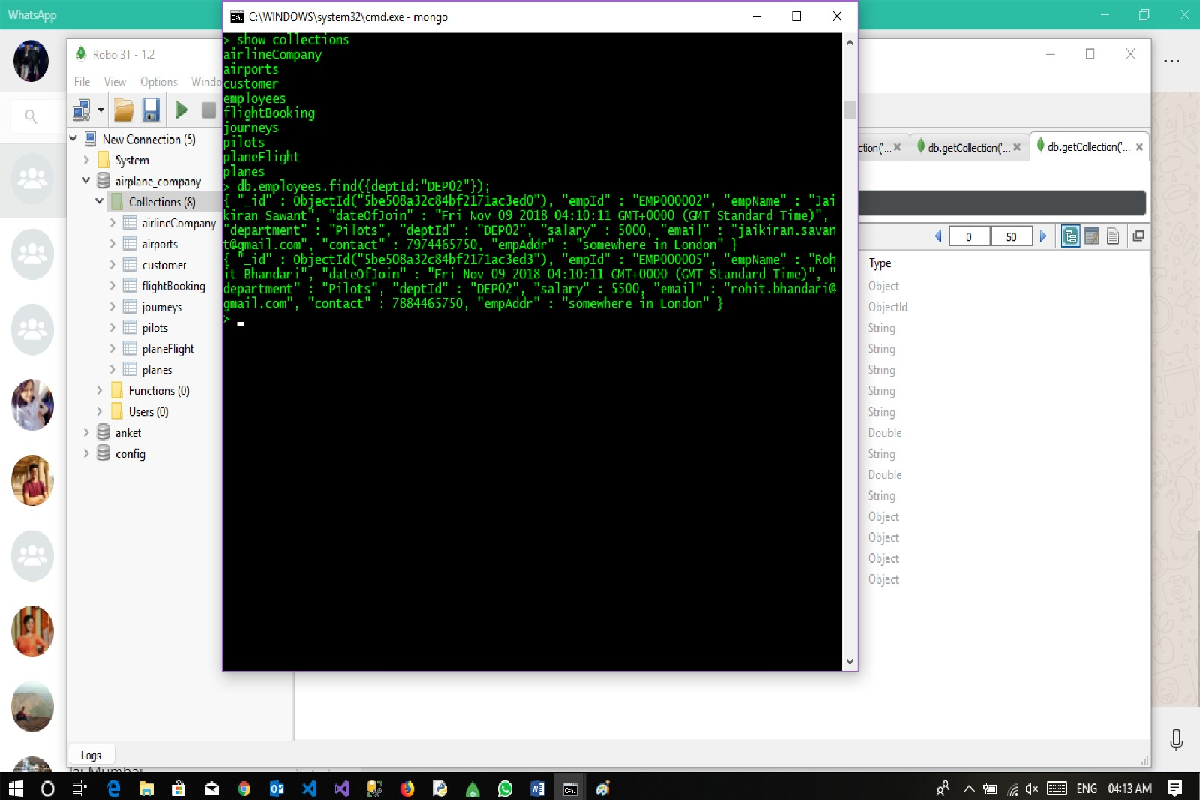

* Note another way of showing the data is by giving the output in JSON format. We can do that by using the pretty() function
  + db.employees.find({deptId:”DEP02”}).pretty();

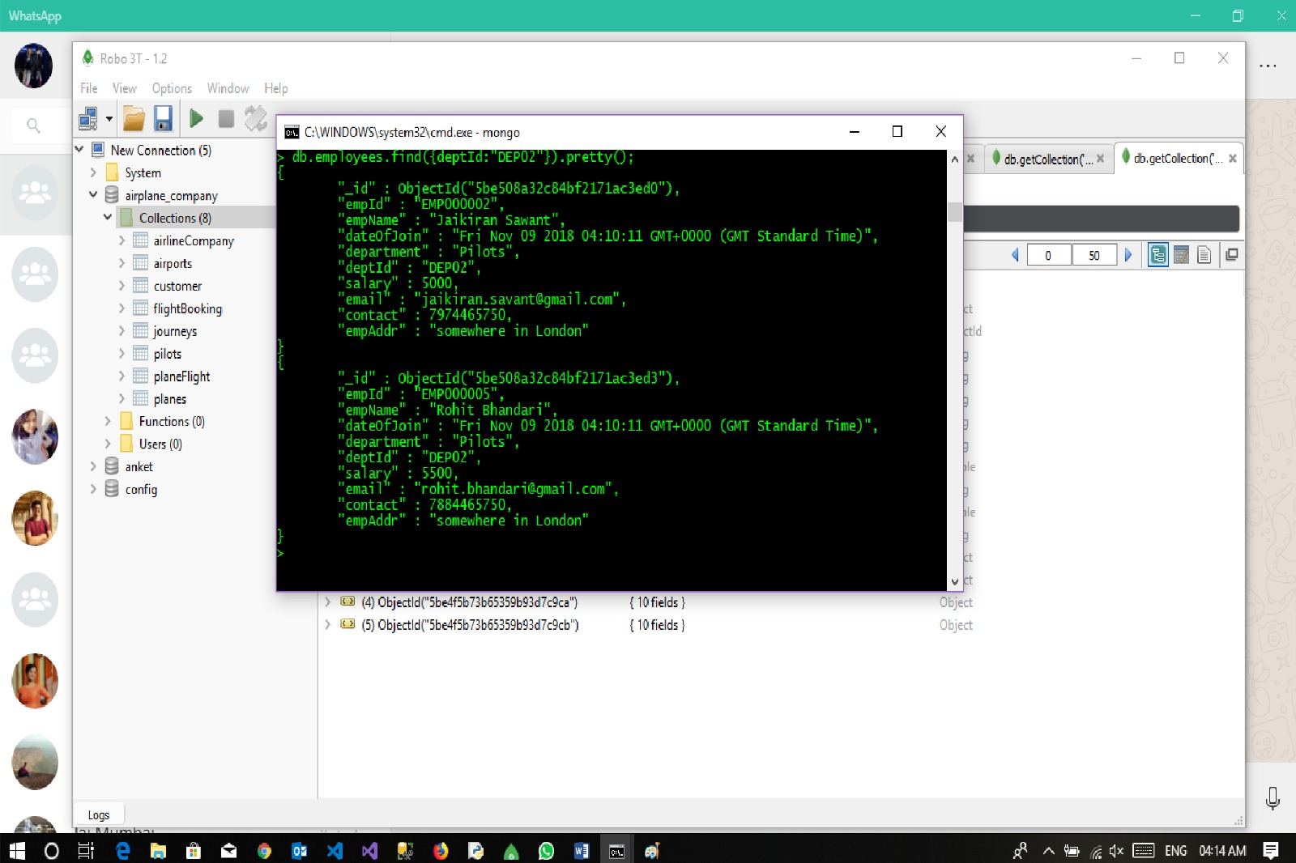

* We can use the below query to check the bookings done by the customers.
  + **db.flightBooking.aggregate([{$lookup:{from:"customer",localField:"bookingId",foreignField:"bookingId",as:"data"}}]).pretty();**

